After completion of the course post the certification and tag to Rahul

<https://www.linkedin.com/in/rahul-shetty-trainer>

Implicit Wait:

It will keep listening to DOM until it searches the element.

Once it searches the element it will not wait for the entire 5 secs that was mentioned in the script

If searched in 2 secs will execute and move to the next script and will not wait until 5 secs.

To tell the page to be loaded entirely is called Synchronization

Synchronization is of 4 types

Implicit, Explicit, Thread, Fluent.

Common Interview Question:

Difference between Implicit & Explicit?

Implicit Wait:

Wait for n no of seconds before you throw exception ( E.g. Element is not displayed)

If you have given 3 secs- we are telling DOM to wait comfortably wait for 3 secs to load the script then you can fail

Sauce Labs: Cloud Testing with Selenium

What is Cloud Testing?

Cloud: We can execute our Selenium test cases in the VM’s which are not in our control.

For e.g.

In order to execute test cases on Firefox version 24, which is not available with us as it’s an old version. The infrastructure provided by the company is limited, but the client has asked us to execute the test cases on different browser combination and different OS combination. we can’t purchase licence as the project is only for 20 days. Can’t be spent more on infrastructure as it’s more expensive.

Cloud Based Testing:

So, there are third party vendors who have this infrastructure and they have hosted on their servers, so now we will access to those servers and we will execute our Selenium test cases from our local machine to that vendor hosted server.

Cloud Testing Component – Sauce Labs

We can execute Manual & Automation test cases by and run them on cloud using Sauce Cloud.

Need to create an account in Sauce Lab as it’s free for 14 days.

Features

8 concurrent VMs , 90 hours Automated Testing, Unlimited Testing

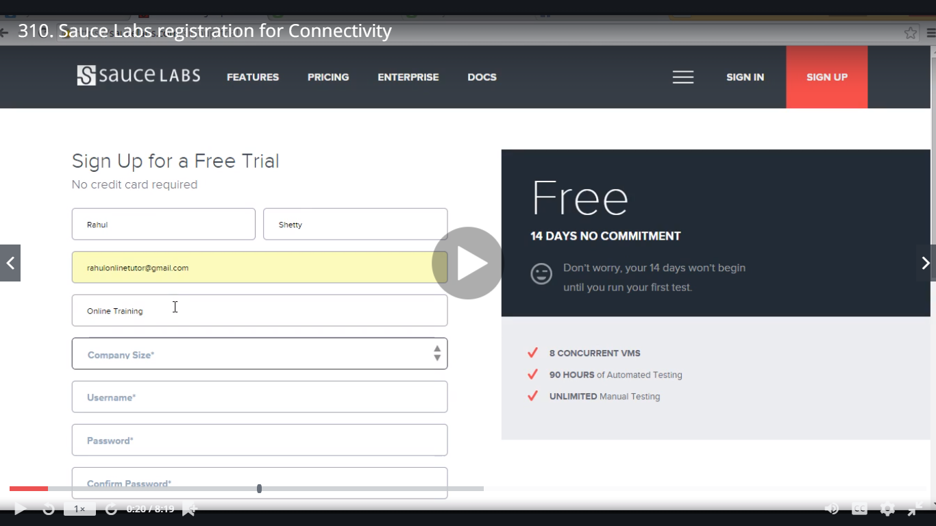

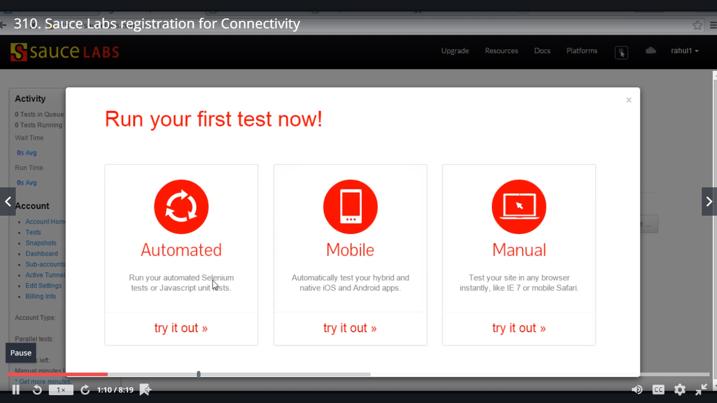

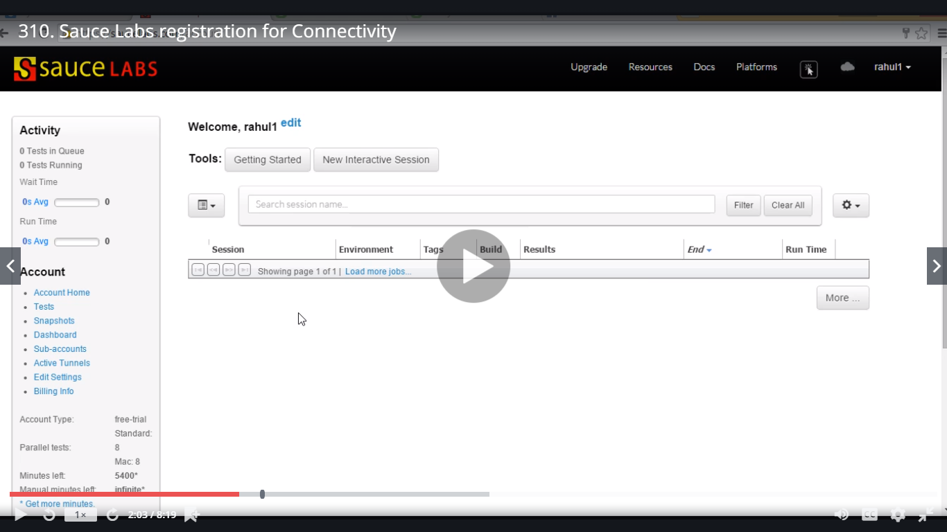

Desired Capabilities

This class is basically used when we run test cases on a server, on a VM

Outside of your local PC scope, cloud computing, when we are running

Appium test cases.

E.g. If we have Mac machine and we want to run on Windows

On Windows machine want to run on Firefox xx version.

Sauce Labs will check for all the VMs 100

Desired Capabilities -will be able to connect between Sauce Labs & our test cases to run on which version and which OS in particular.

It’s very confusing to select which OS, how to select Windows

Sauce Labs have come up with a very beautiful concept using:

<https://wiki.saucelabs.com/display/DOCS/Platform+Configurator#/>

<https://wiki.saucelabs.com/display/DOCS/Getting+Started+with+Selenium+for+Automated+Website+Testing>

Jenkins:

Job

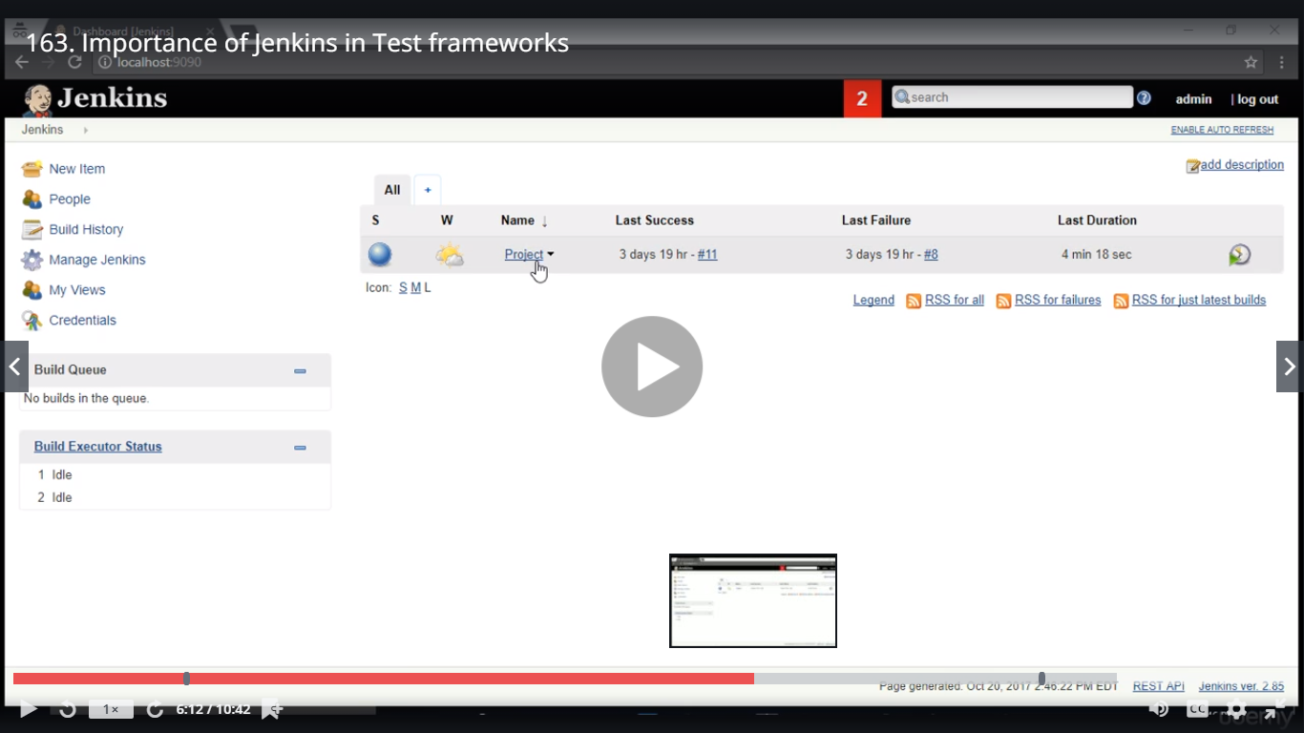

In this Project we have 500 to 1000 test cases:

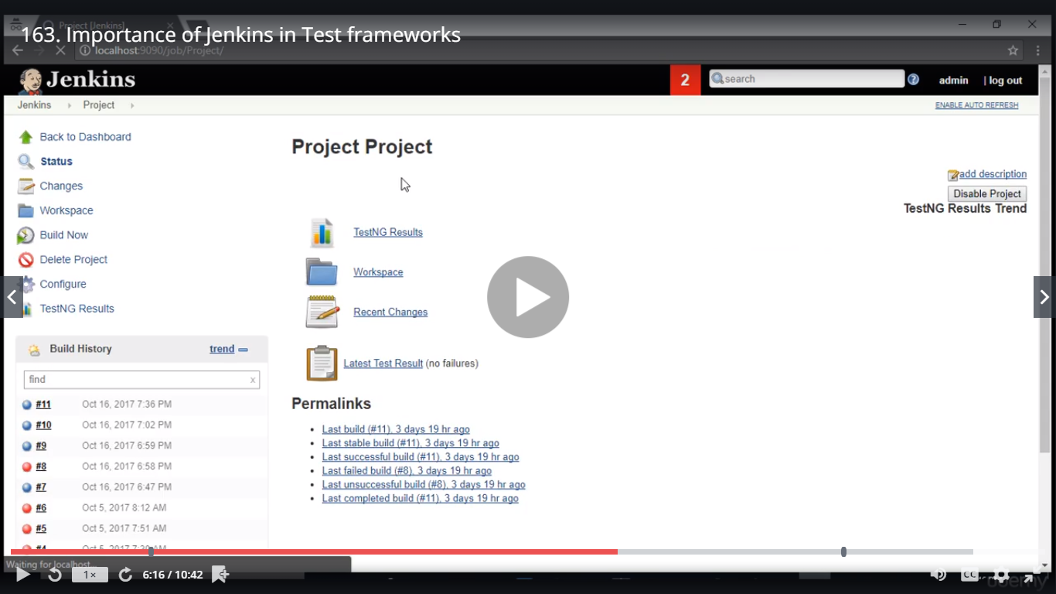

Click on Build Now

After clicking on Build Now all the execution will start automatically

Here Manager will just take the Jenkin URL and click on TestNG Results link and check the status of the test cases as in how many passed,failed & skipped

Jenkins runs on its own server

Real time Scenario:

My scripts are failing in my machine but are getting passed in Jenkins

It my be the case where in I might have updated jars in my local machine where as in Jenkins it have old version jars or vice versa.

Generally DevOps guys will install Jenkins in our company – Real time

Here we will see localhost://8080 but in company it will be as [xyz@cognizant.com](mailto:xyz@cognizant.com)

Maven project will integrate with CI tool Jenkins

Jenkins guys have provide plugins and command tools and will accept Maven commands to run which are developed in Maven project

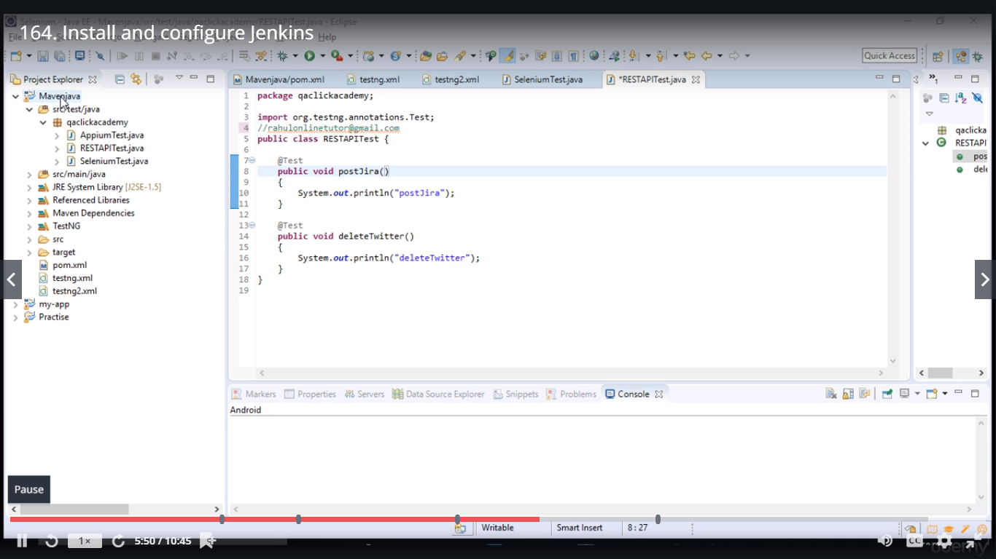

Manage Jenkins

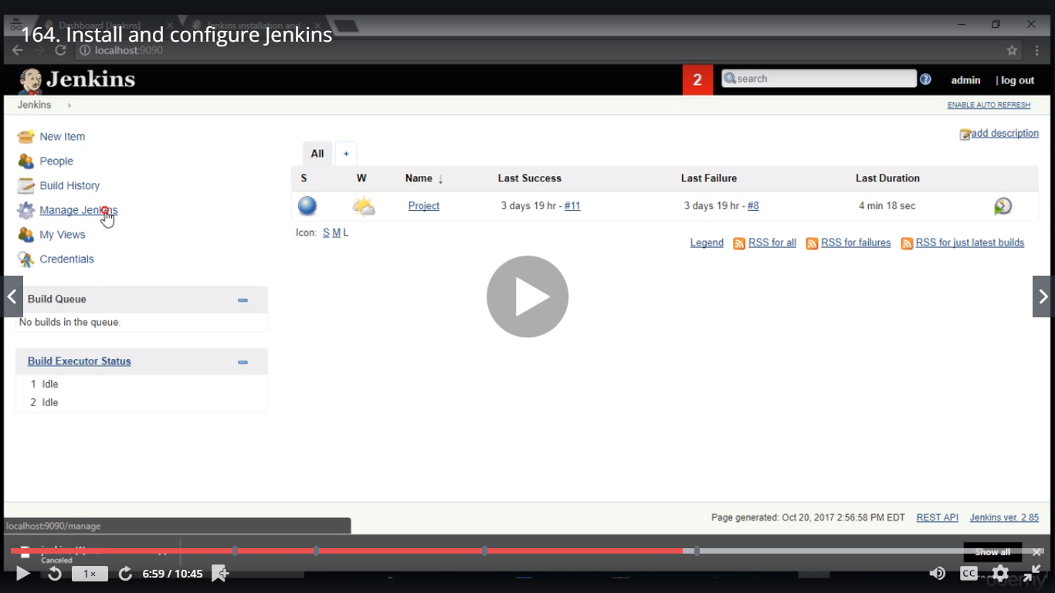

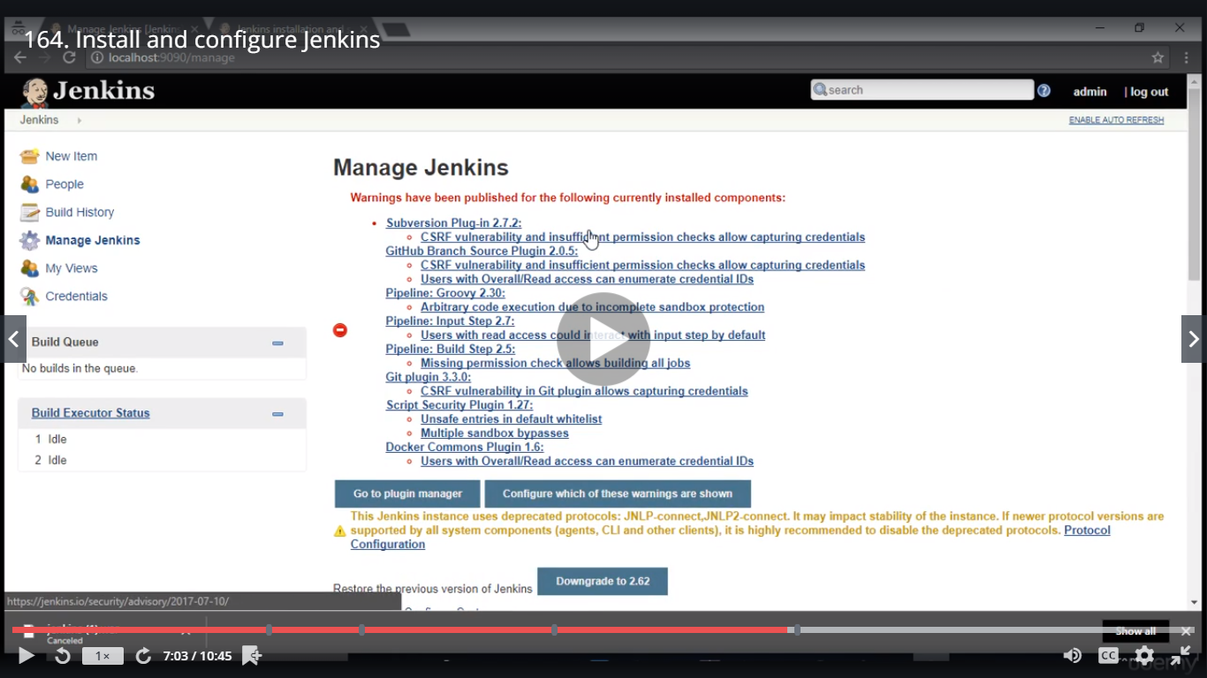

Global Tool Configuration

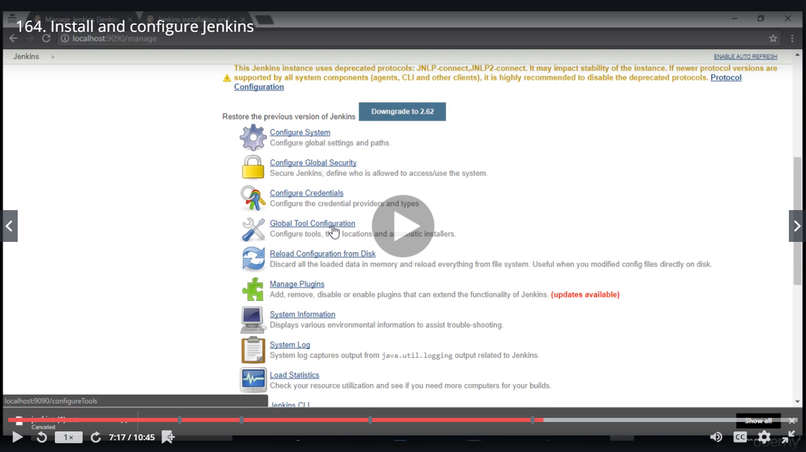

JDK

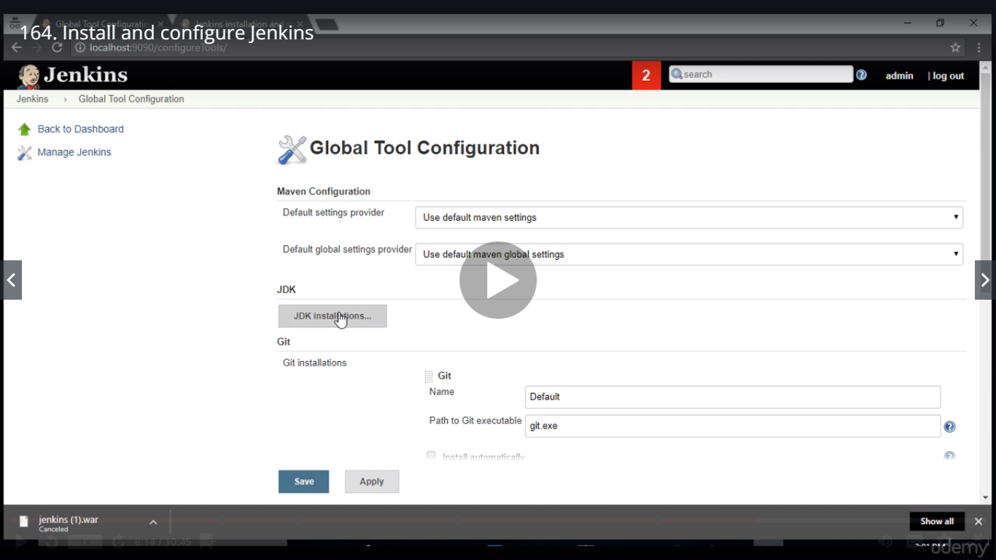

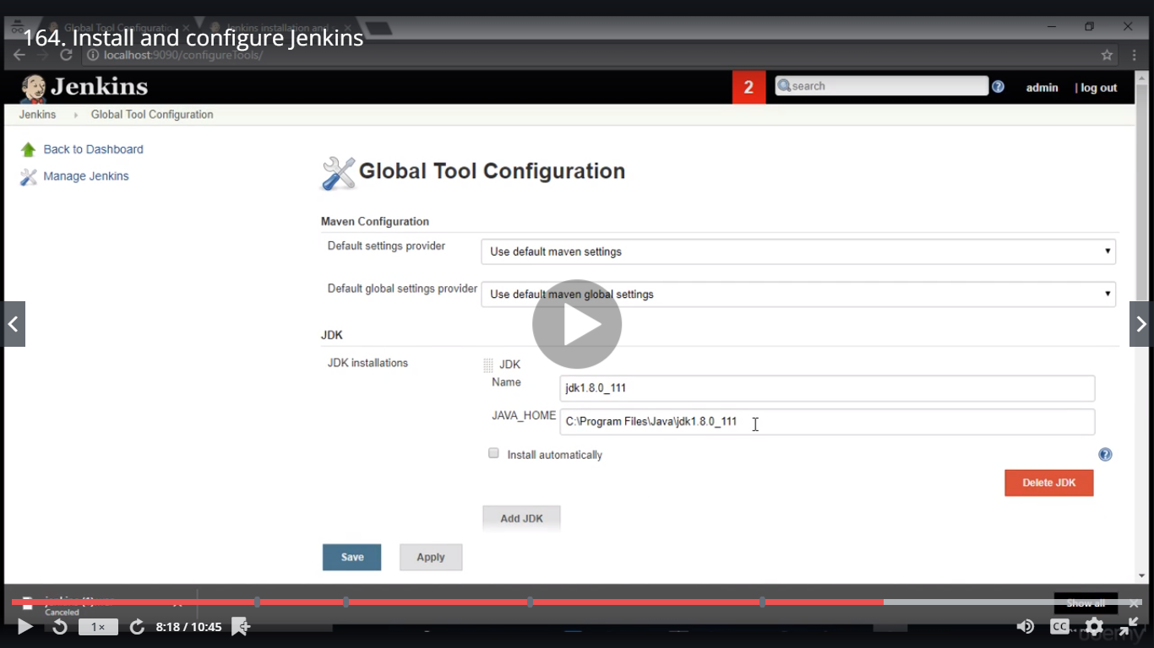

Install automatically

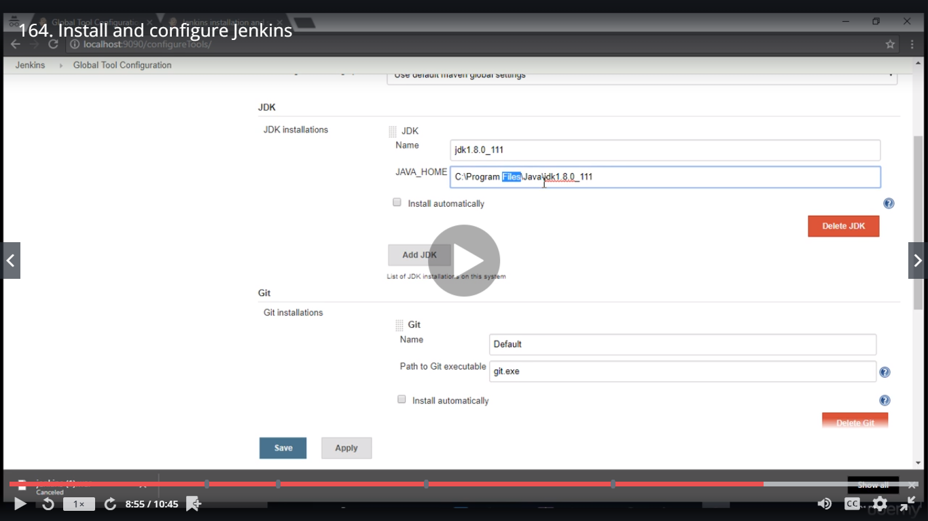

Maven Installation

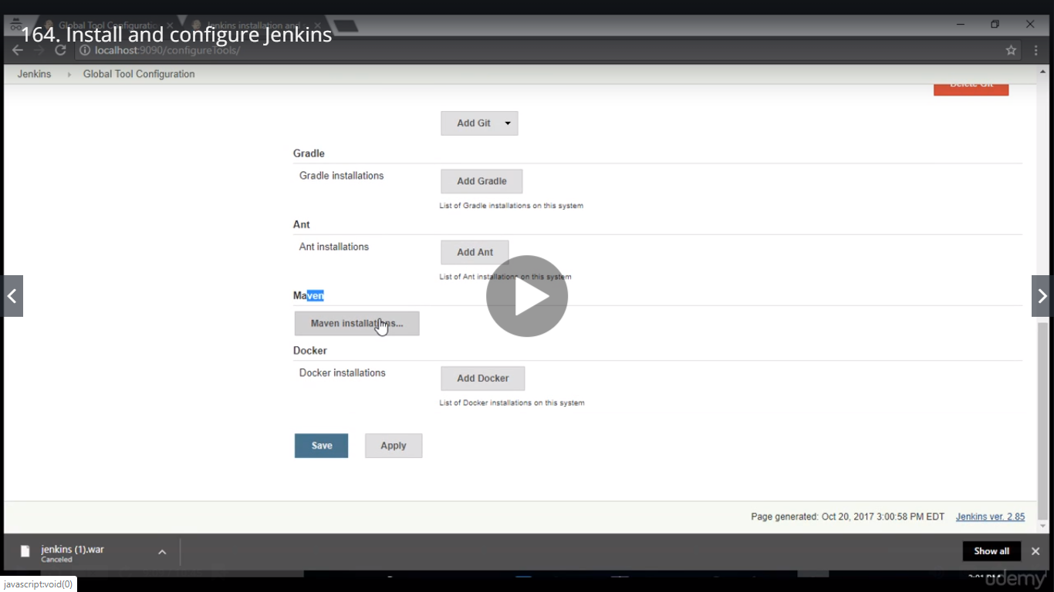

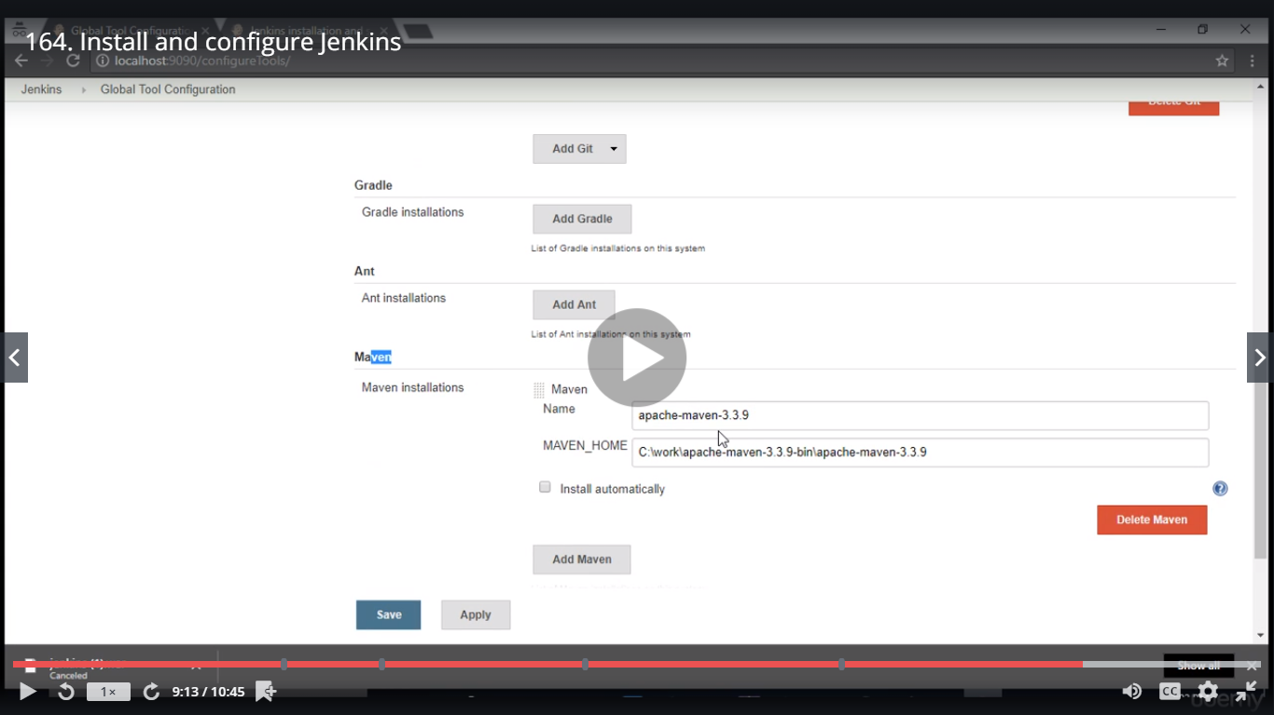

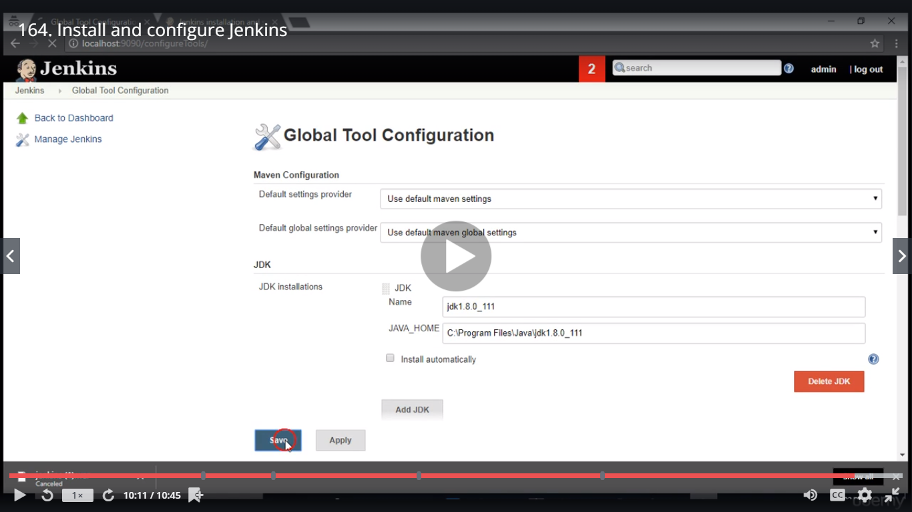

Click Save

New Item

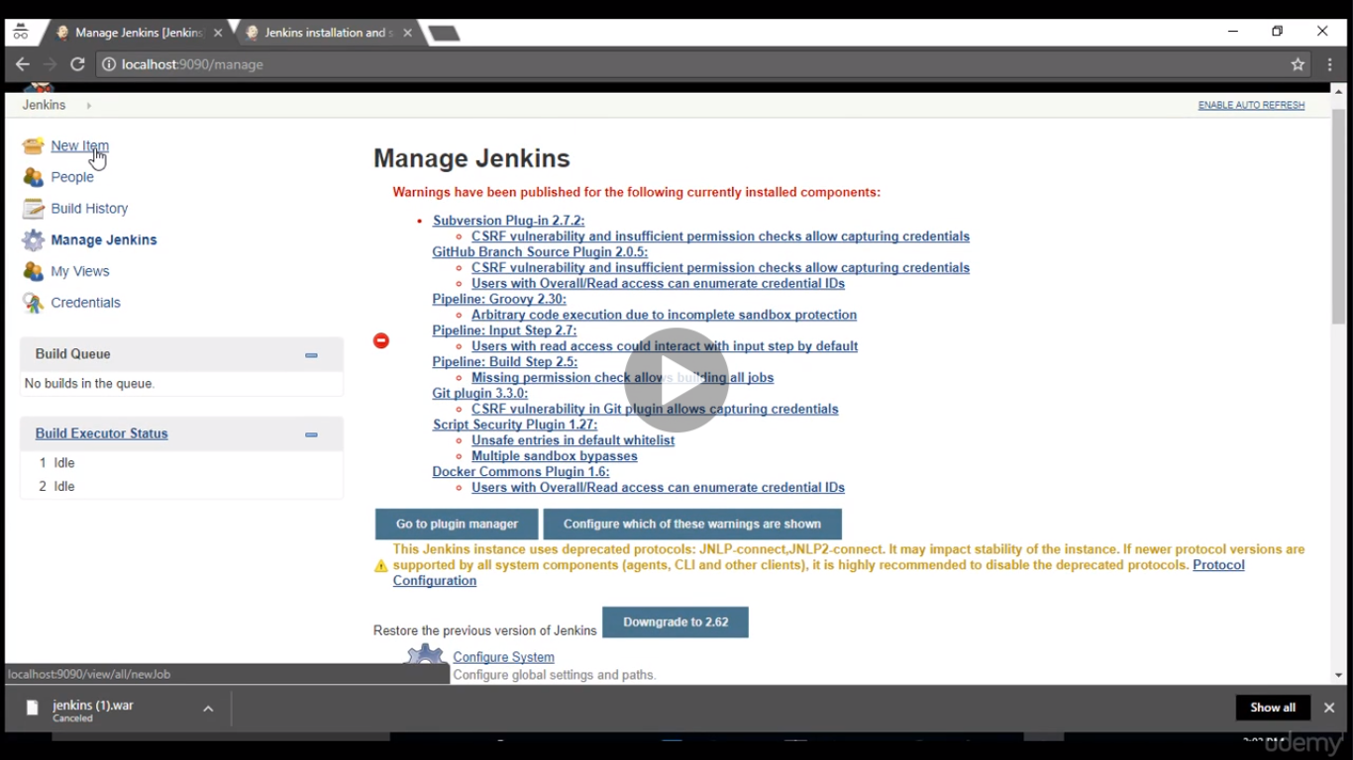

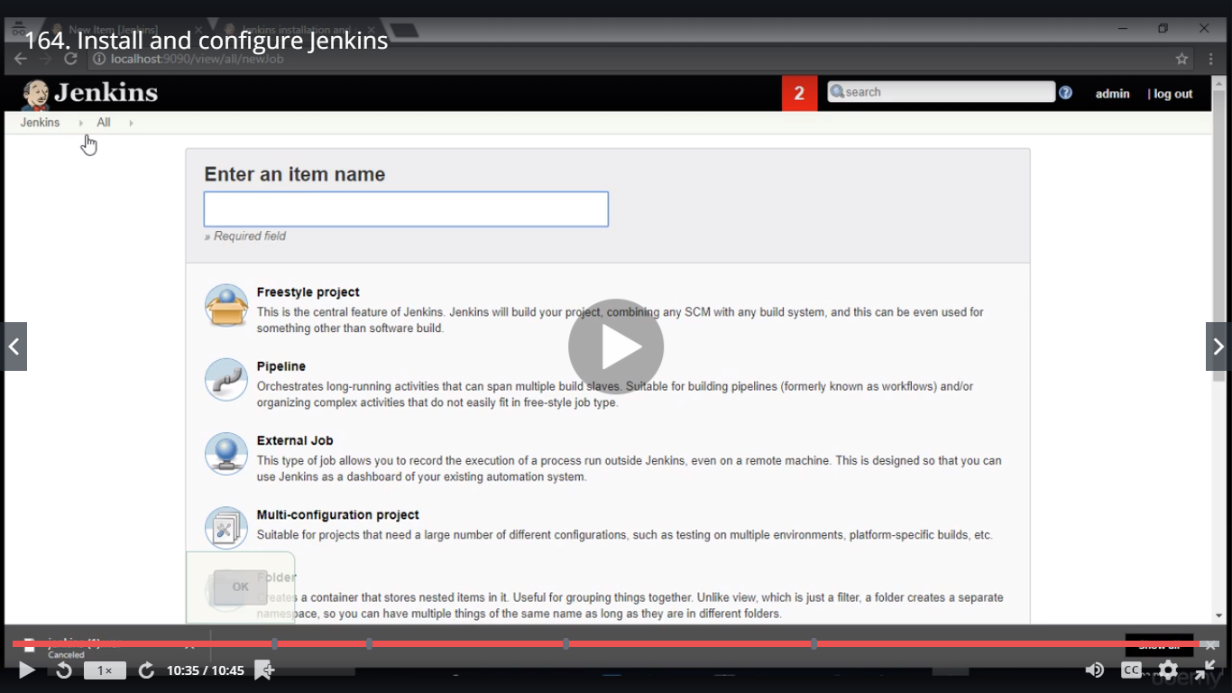

New Job to create Maven Project

Type MavenJob ; Then Freestyle Project ; Click on Ok

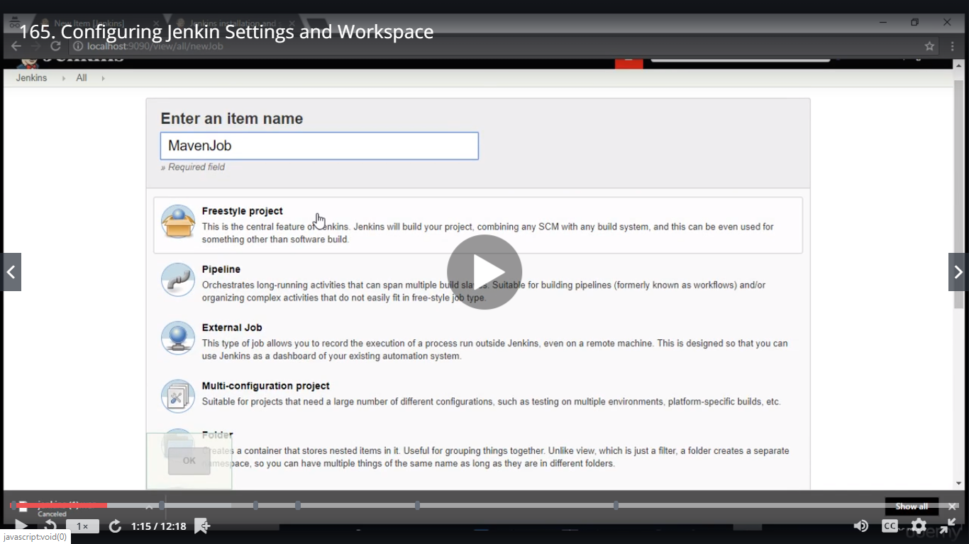

It opens a job configuration window

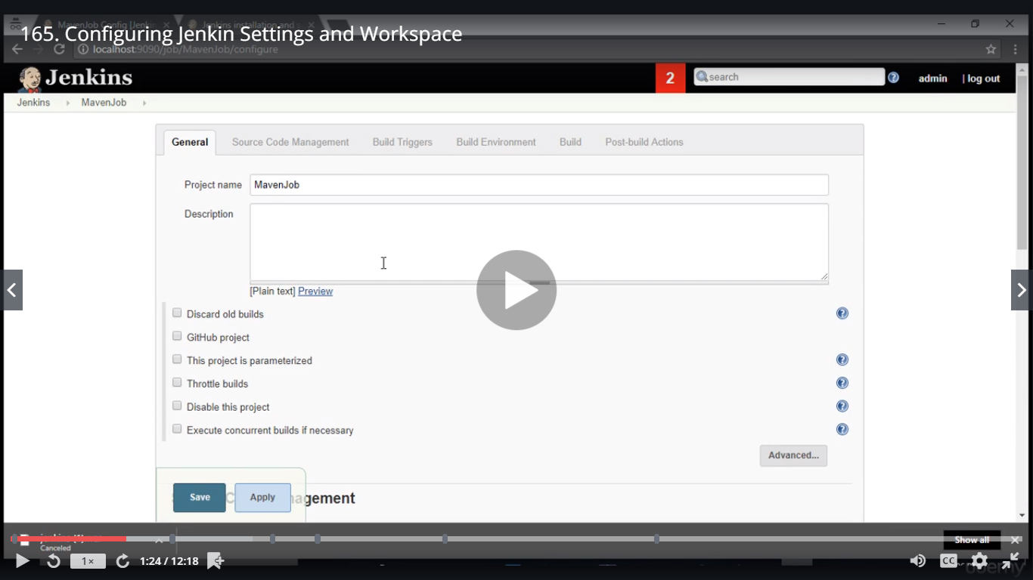

In Real time code will be pushed through Git

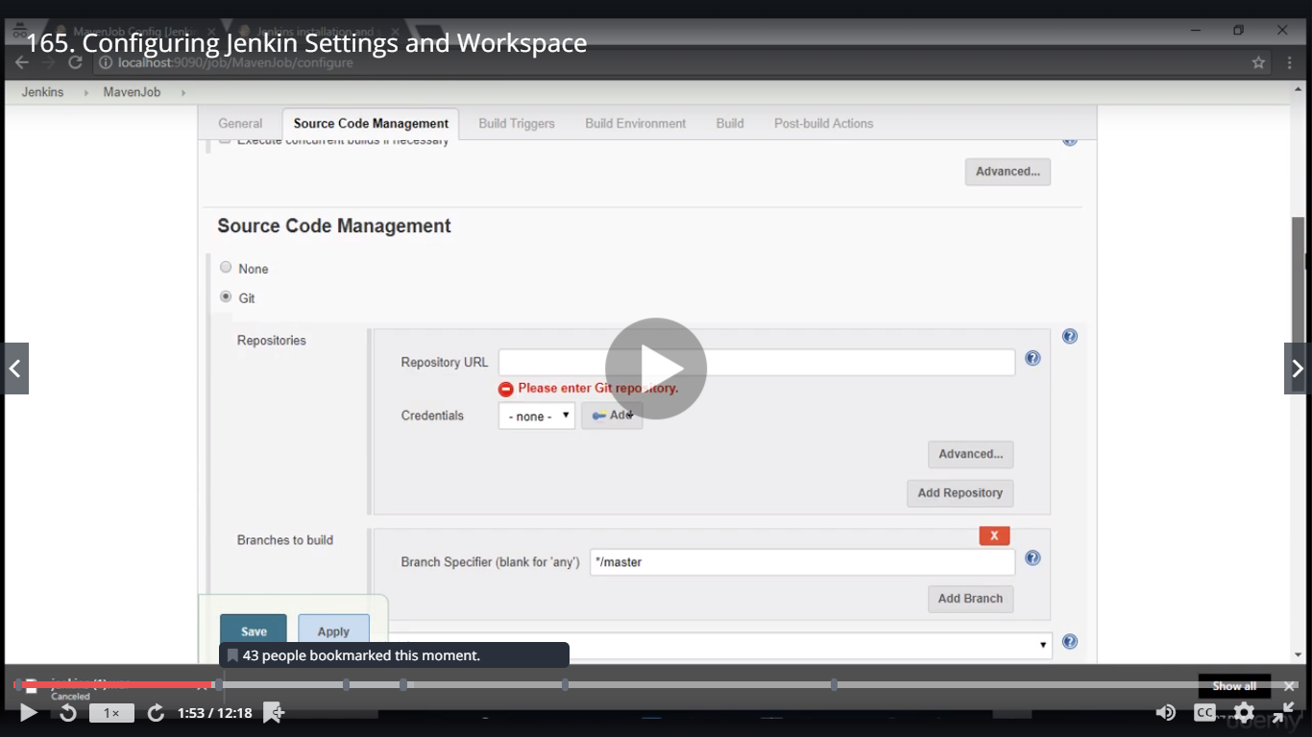

Copy Maven Project from Eclipse

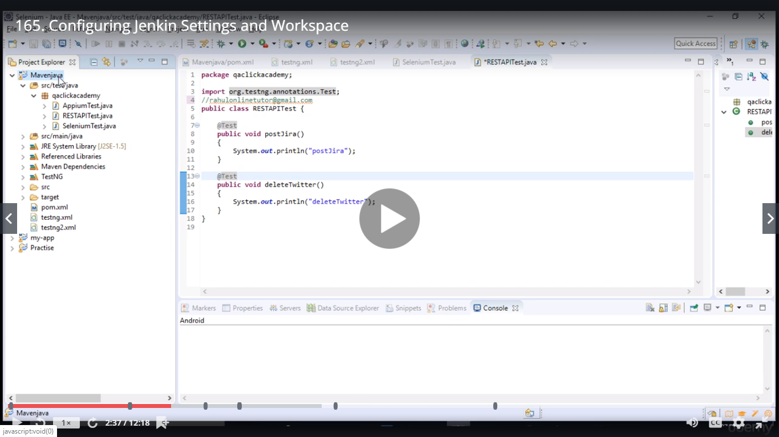

Jenkin Home Directory

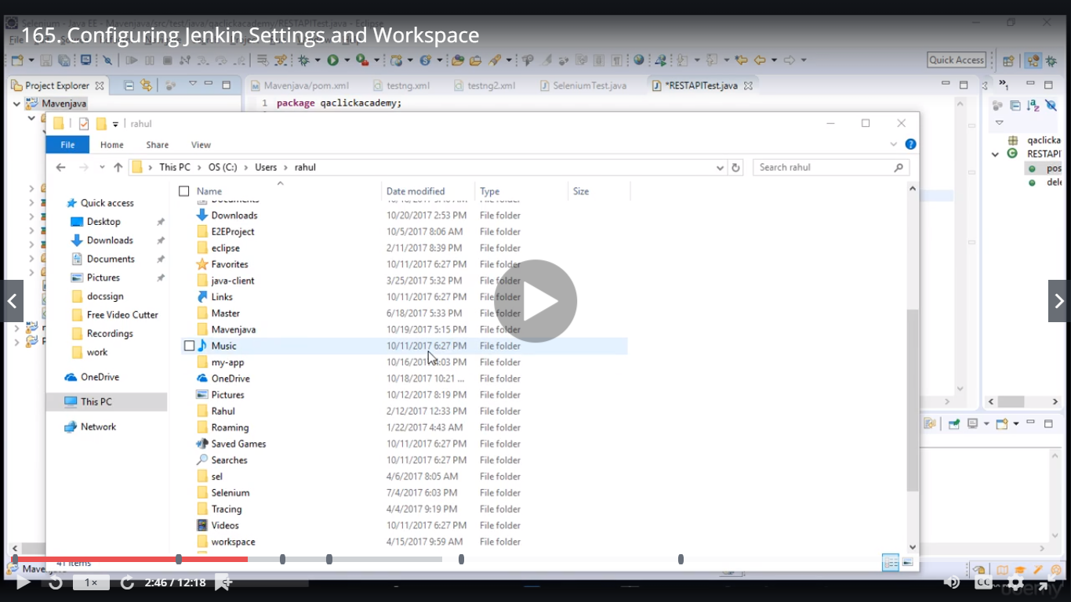

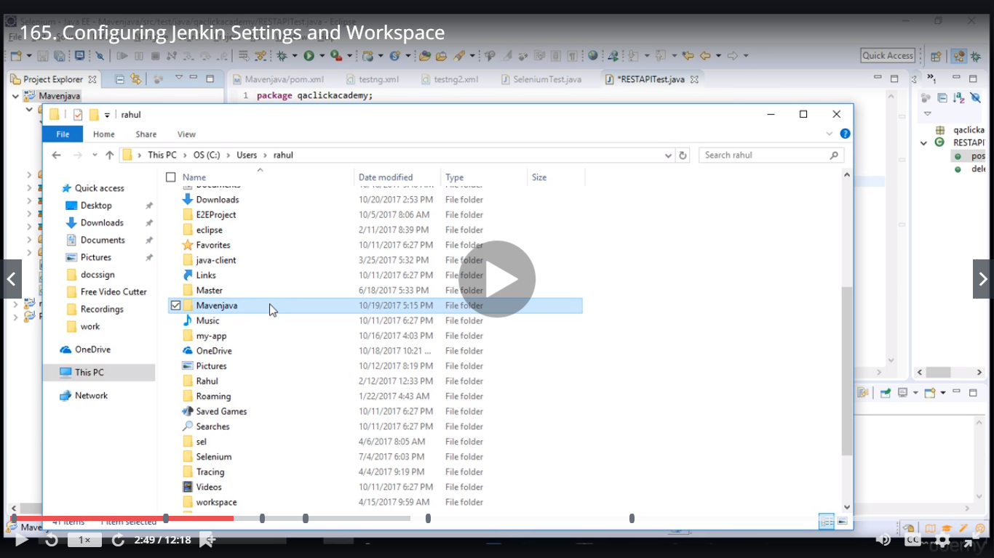

Go to .jenkins folder

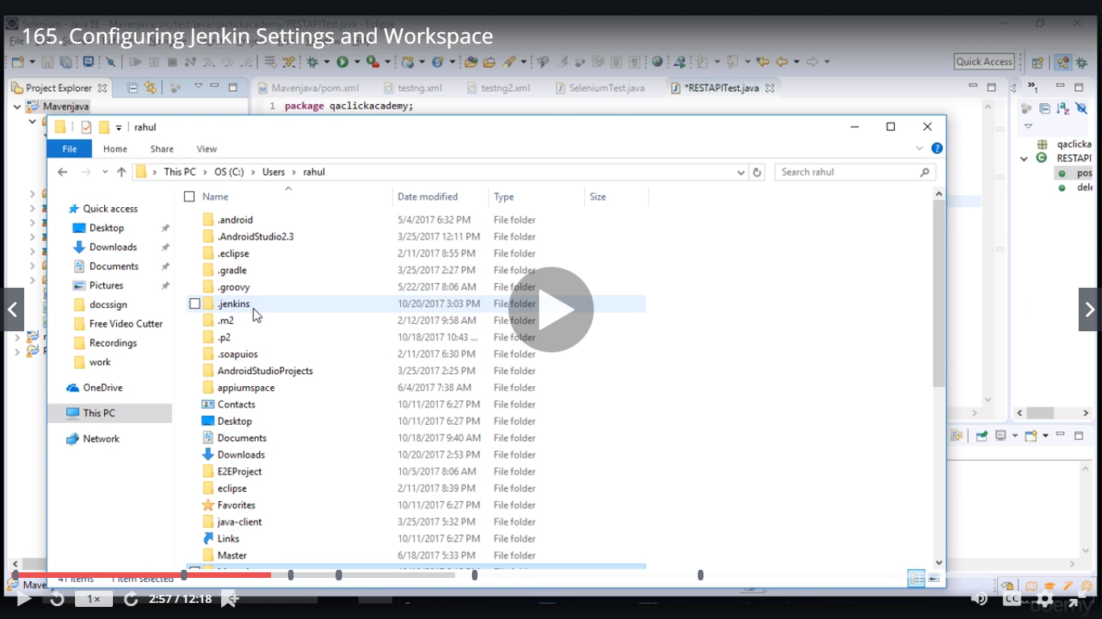

Paste Mavenjava in this folder

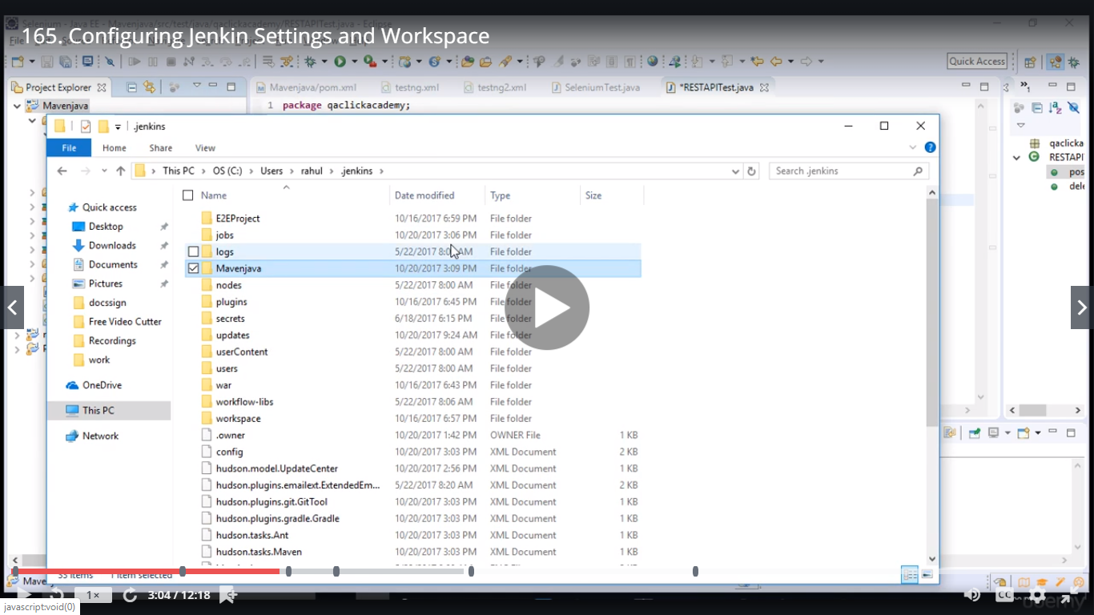

Need to set path for Mavenjava

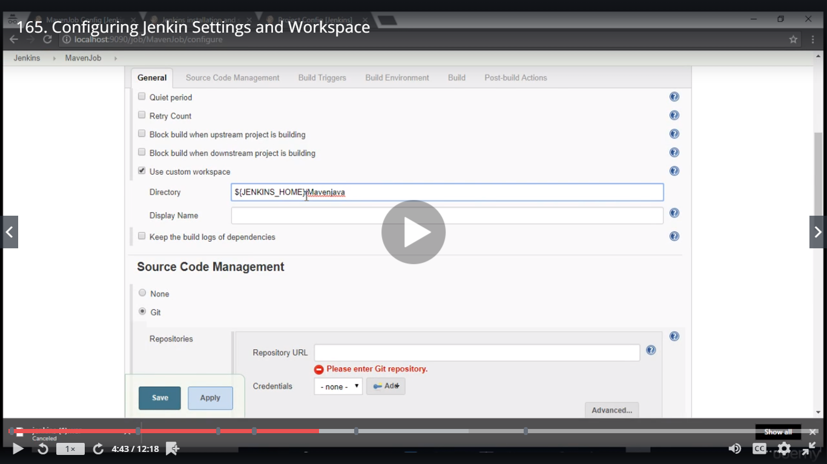

To set time periodically

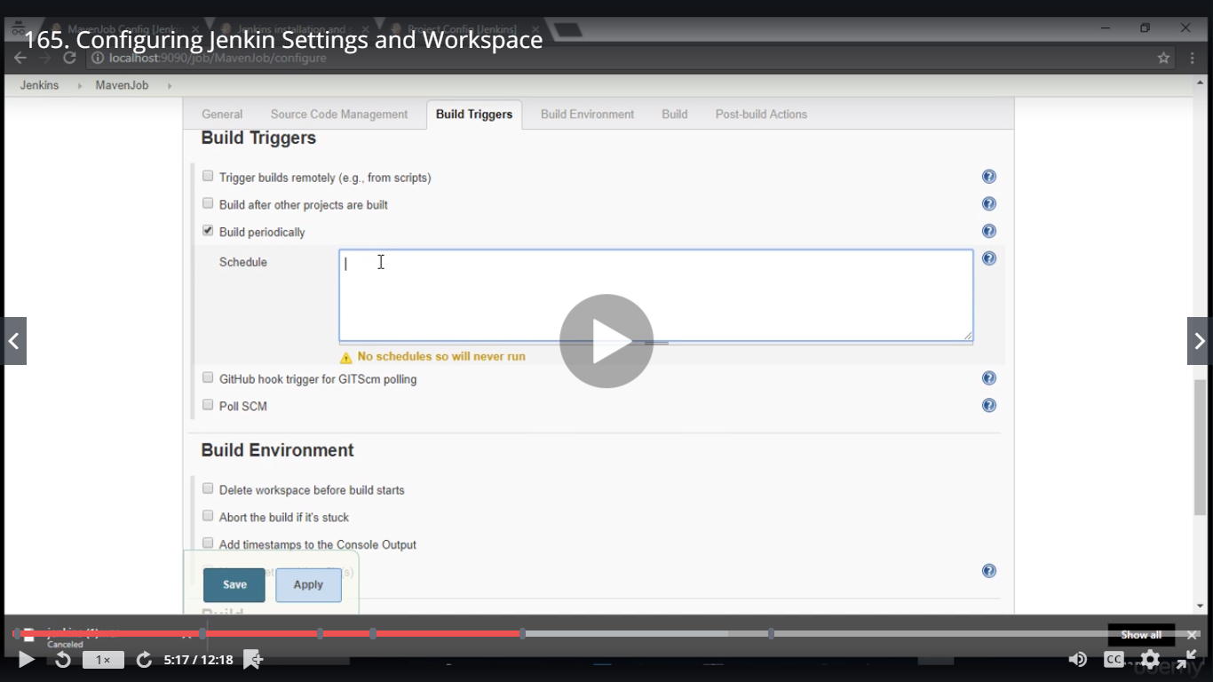

To run the pom.xml which is in Mavenjava

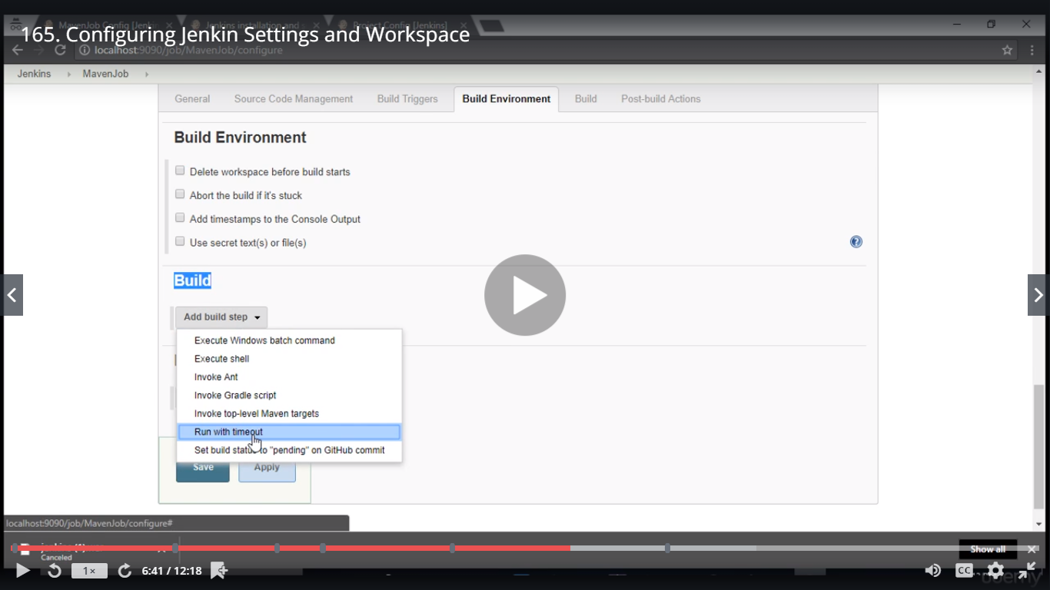

Invoke top-level Maven target

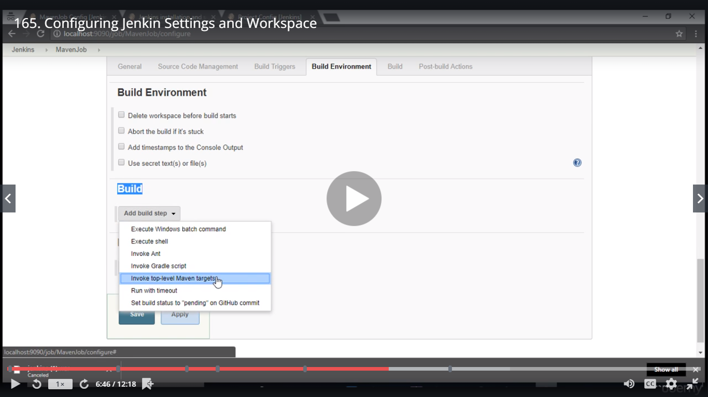

Once configured it will be seen in the dropdown

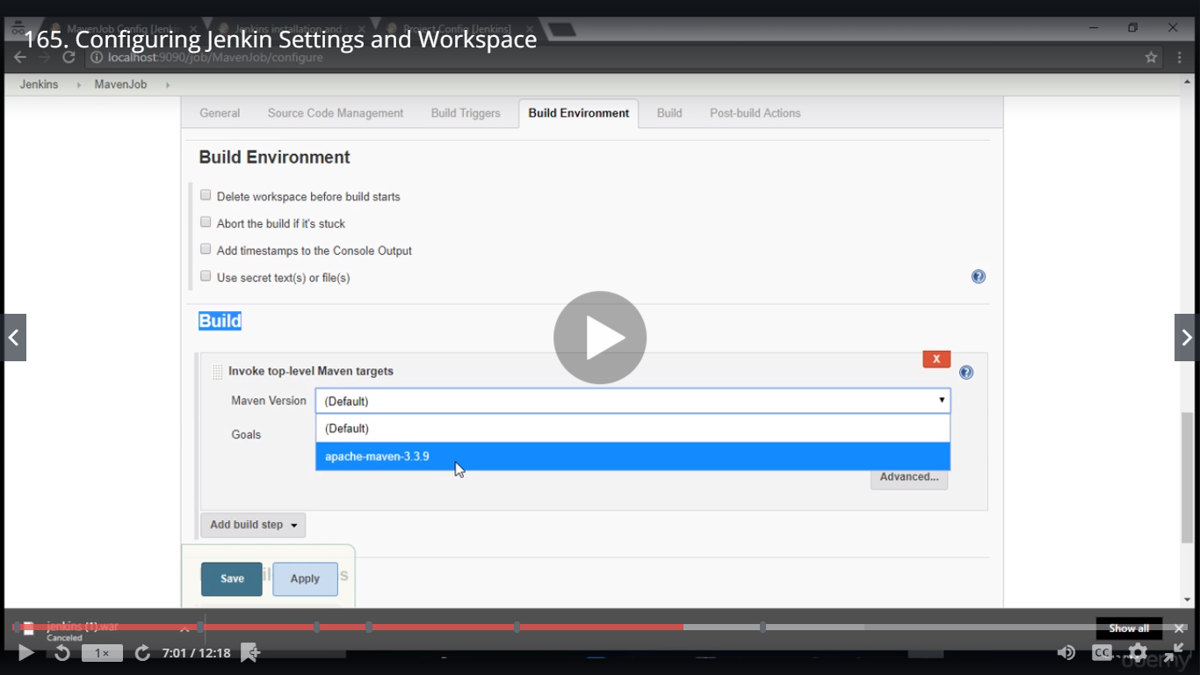

In Goals: mvn test – PRegression ( you can remove mvn)

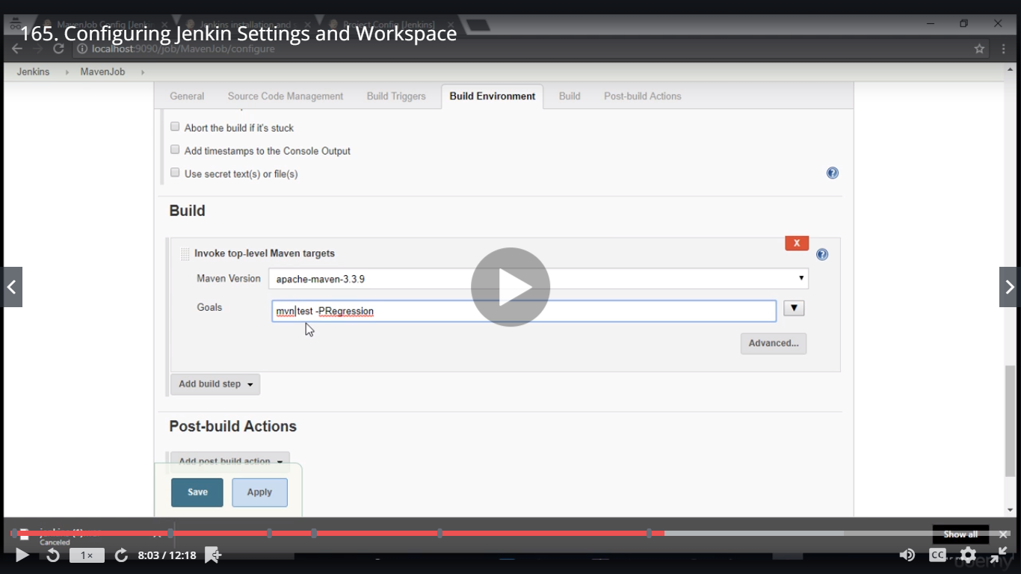

Then Save

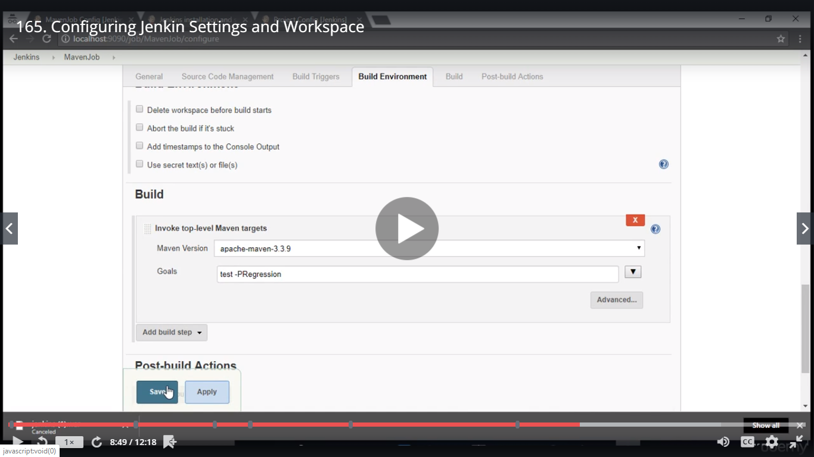

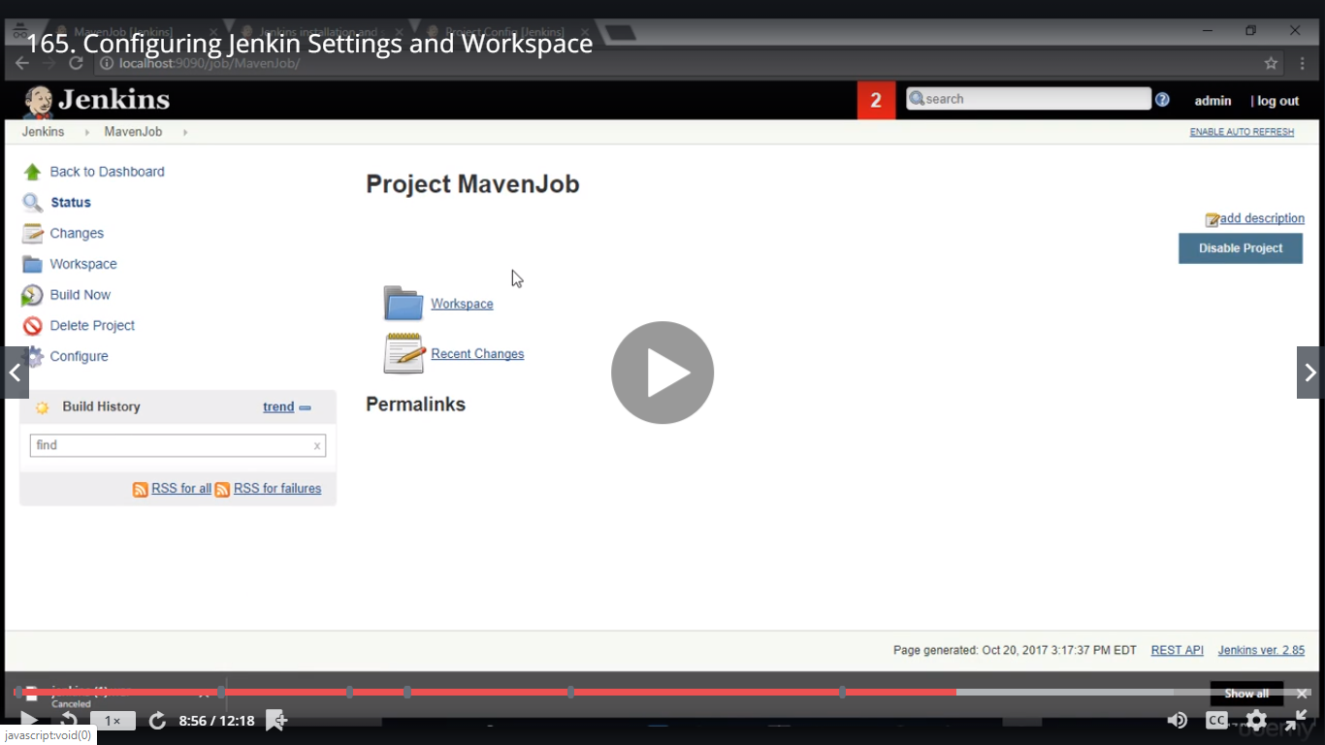

Client will check if Regression is done or not by clicking on Build Now without any knowledge on Maven,Jenkins

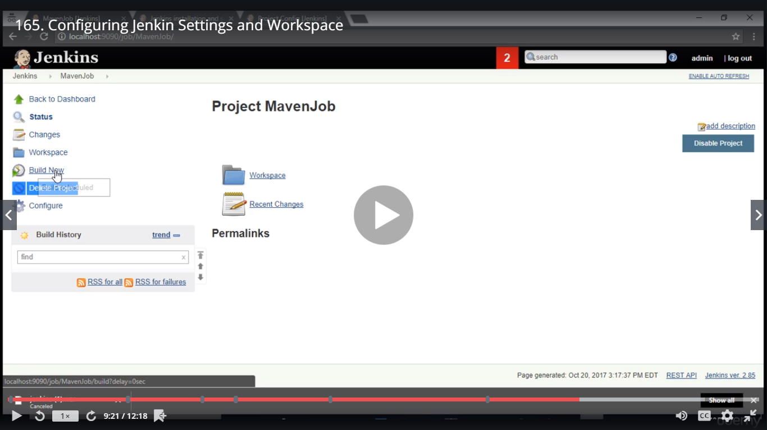

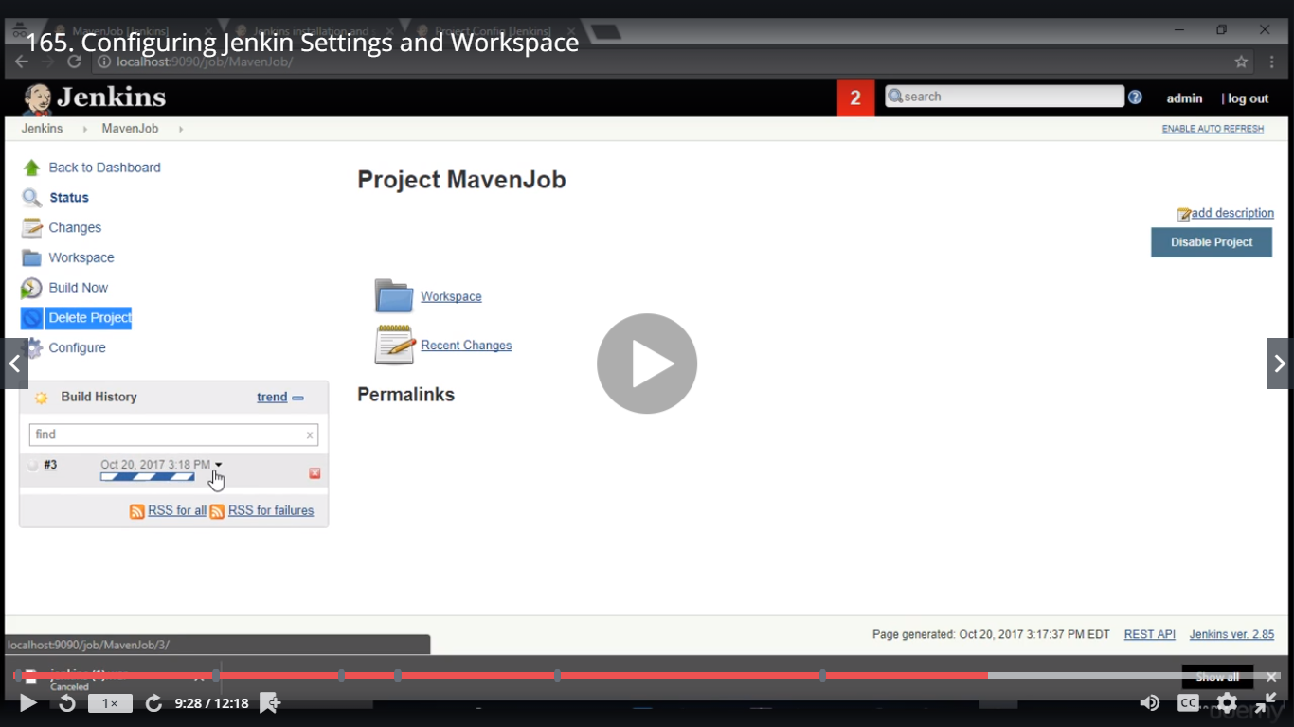

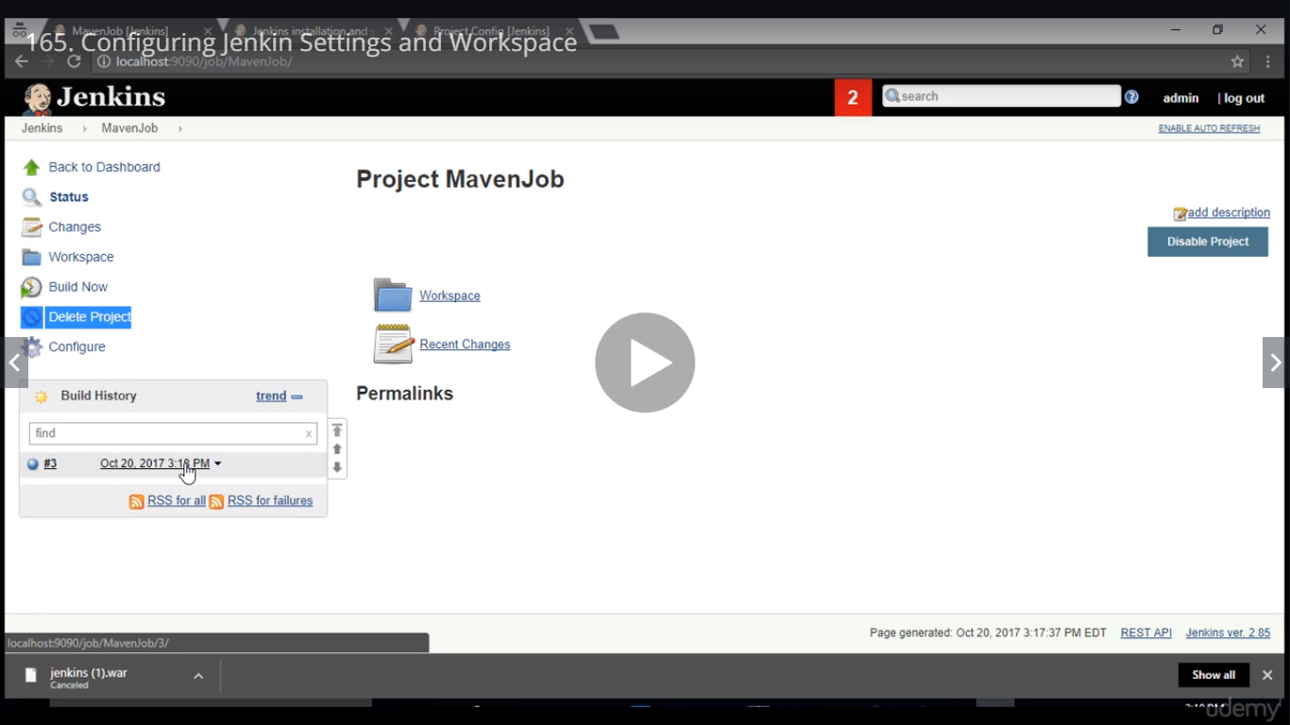

Console Output

